Project Development Phase Model Performance Test

Date | 25th January 2026
Team ID | LTVIP2026TMIDS87096
Project Name | Project – Online Fraud Detection System
Maximum Marks | 10 Marks

Model Performance Testing:
Project team shall fill the following information in model performance testing template.

S.No. | Parameter | Values | Screenshot
1. | Metrics | Classification Model: Confusion Matrix – Accuray Score- Classification Report - | 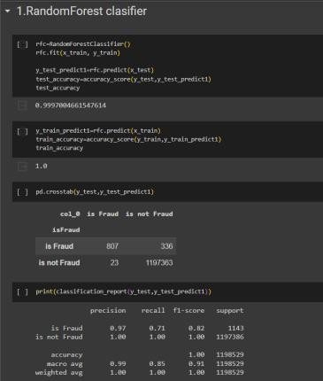  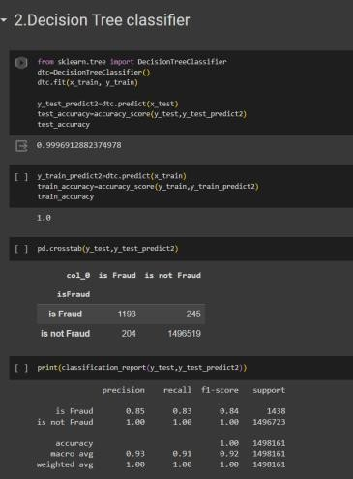

 |  |  | 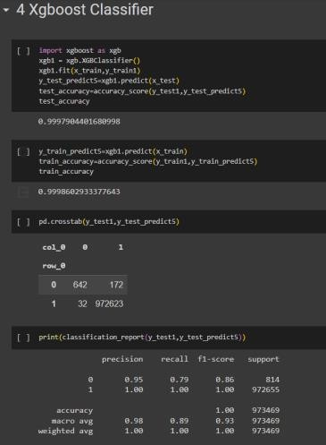
2. | Tune the Model | Hyperparameter Tuning - | The accuracy for the model is high without hyperparameter tunning and  the type 2 error is also very low.

